

PROPOSAL DOCUMENT

Vulnerability Assessment &
Penetration Testing (VAPT) Report

4Africa Data Specialists

14 December 2023
© Sautech (Pty) Ltd. http://www.sautech.net

TABLE OF CONTENTS

1 Executive summary 2
2 scope of testing 3
3 Methodologies used 3
3.1 Nessus 3
3.2 Greenbone Enterprise 3
4 Stay One Step Ahead of Attackers 4
5 Infrastucture 4
5.1 41.76.213.236 4
6 Reporting Conclusion 7
7 Auditors 8

Executive summary

The purpose of this assessment was to point out security loopholes, business logic errors, and missing best security practices. The tests were carried out assuming the identity of an attacker or a malicious user but, no harm was made to the functionality or working of the application / network. A full scan was also performed on the infrastructure to demonstrate a known attack, i.e. someone on the internal network or same public subnetted infrastructure. The scans and were performed over 6 (six) business days, as full and slow comprehensive audits were performed. These types of scans also look at unknown connectivity options, including packet SYN requests.

The overall results will be published below. Some recommendations however, is offered and also mentioned throughout this document.

scope of testing

Security assessments include testing for security loopholes in the scope defined below. Apart from the following, no other information was provided. Nothing was assumed at the start of the security assessment. The following scope of servers were covered under the security audit:

- Server hosted at Afrihost – 41.76.213.236

Methodologies used

Sautech performed various audit techniques that includes the following:

Nessus

Nessus is a remote security scanning tool, which scans a computer and raises an alert if it discovers any vulnerabilities that malicious hackers could use to gain access to any computer you have connected to a network. It does this by running over 1200 checks on a given computer, testing to see if any of these attacks could be used to break into the computer or otherwise harm it.

Greenbone Enterprise
Greenbone is the world’s most widely used vulnerability management provider.

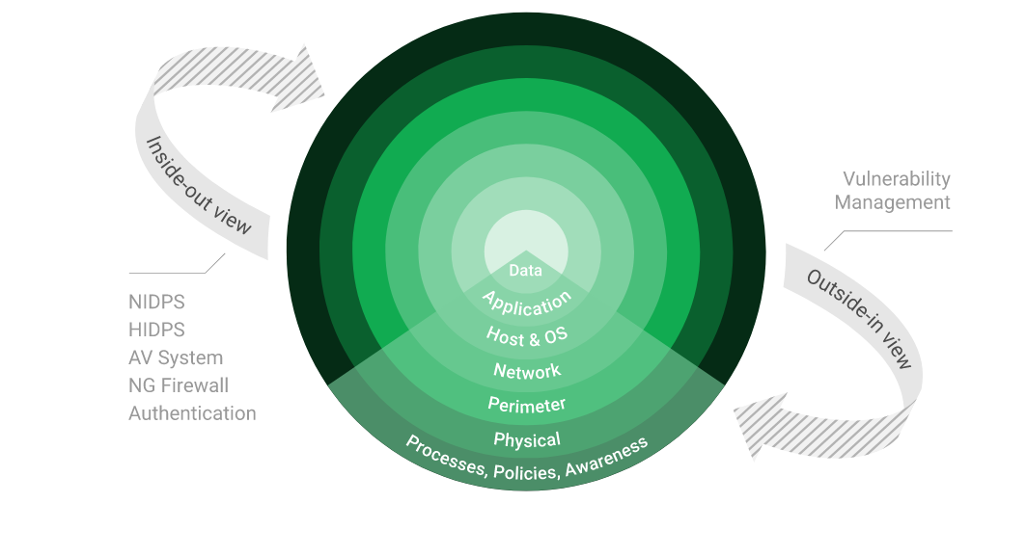

Stay One Step Ahead of Attackers
IT security is a process – Open Source vulnerability management provides the foundation. Once you know where the chinks are in your armor, you can do something about them.

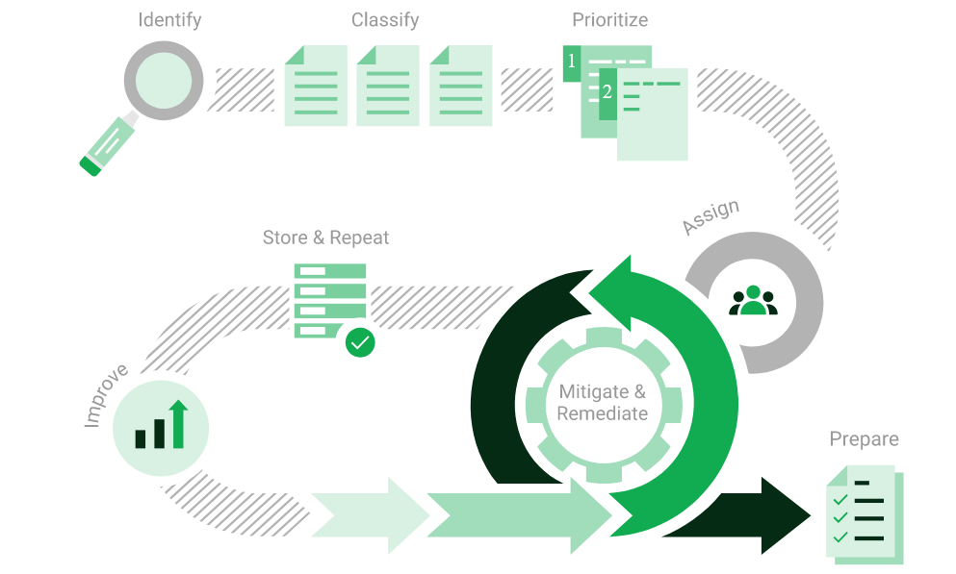

The process – from recognition to remedy and monitoring – represents a continuous cycle. You’ll always be one step ahead of attackers.

Infrastucture

41.76.213.236

We have performed three types of scans / attacks on the production server namely:

- Vulnerability Assessments.

Vulnerability Assessment
Multiple technologies were used to perform a vulnerability assessment, below is the summarised version of the relevant results:

We have attached the below “highlight” in a separate report so that you can click on the “Plugin” link to get the resolution.

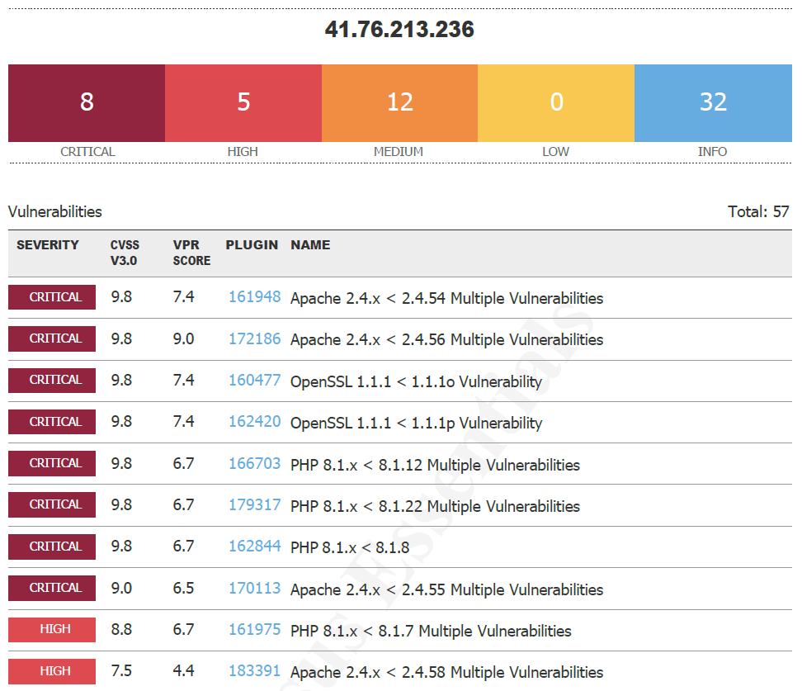
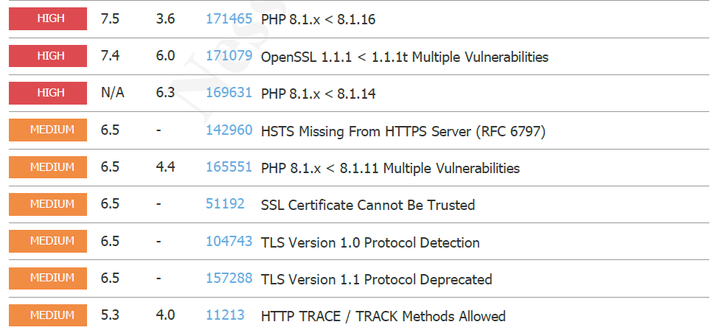

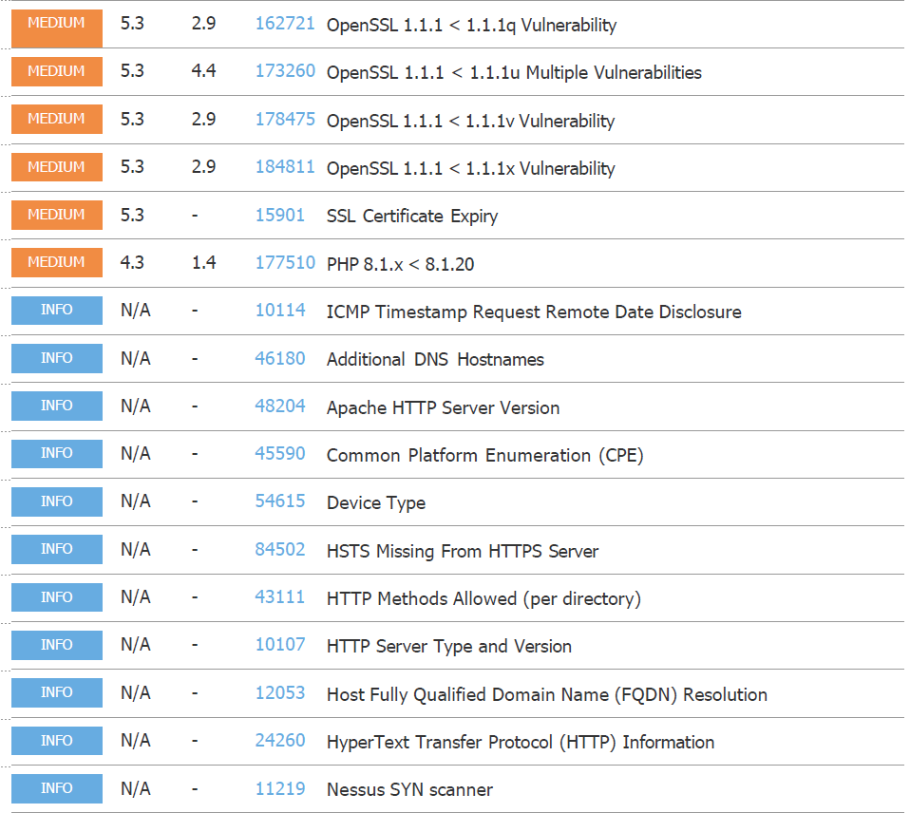
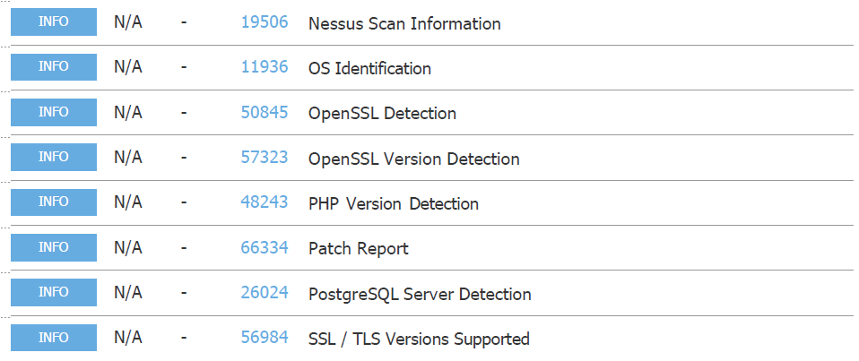

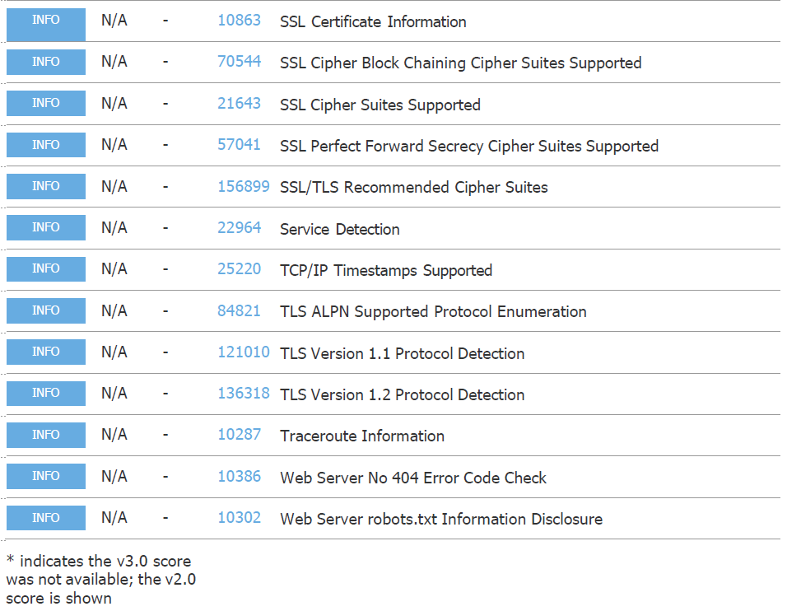

Reporting Conclusion

Based on the reports, it is best to attach these separate to the reporting document. These reports can then be shared with the relevant contractors and/or support personnel to implement the changes and updates.

The HTTPS/TLS updates as these are open to the public, low and medium risk, should be tested and implemented as soon as possible.

We do recommend that SenitnelOne is implemented into the production environment as soon as possible.

Two addendum reports are attached to this report and should be read as one document.

With the following test performed:

- External HTTP and Port exploits
- Vulnerability assessment on CVE
- Penetration testing on login ports i.e.: ssh open

Auditors

These audits were concluded over a period of 6 (six) days.
We hereby confirm that the above information is true and correct:

14th December 2023 – Krugersdorp, South Africa

_________________________ _________________________
Riaan van Jaarsveld Lukas Janse van Rensburg
Security Expert – CCSA / Certified Pen Tester Security Engineer

